K Bharath Sanjay
1925122324

Exp No:16 SERIAL INTERRUPT USING UART (KEYBOARD INPUT) IN KEIL
AIM:
To write and simulate an Embedded C program using serial interrupt in 8051 microcontroller such that while a message is continuously transmitted, any key pressed from the keyboard generates an interrupt and is displayed through UART.
APPARATUS / SOFTWARE REQUIRED:
• PC with Windows OS
• Keil µVision IDE
• 8051 Simulator (Keil built-in)
• Serial Window (UART #1)
THEORY:
The 8051 microcontroller provides a serial interrupt that occurs when:
• RI (Receive Interrupt flag) is set after receiving a character, or
• TI (Transmit Interrupt flag) is set after transmission.
In this experiment:
• UART is configured in Mode 1 (8-bit UART)
• Timer1 is used to generate baud rate (9600)
• Serial interrupt is enabled using ES bit
• When a key is typed in the Keil Serial Window, the received character sets RI
• The Serial Interrupt Service Routine (ISR) is executed immediately This demonstrates interrupt-driven serial communication, which is more efficient than polling.
PROGRAM:
#include <reg51.h>
#include <stdio.h>
void serial_ISR(void) interrupt 4
{
char ch;
if (RI)
{
RI = 0; // Clear receive interrupt flag
ch = SBUF; // Read received character
printf("\n>>> INTERRUPT RECEIVED: ");
printf("%c\n", ch);
}
}
void delay(void)
{
unsigned int i;
for(i = 0; i < 50000; i++); // Delay for visibility
}
void main(void)
{
SCON = 0x50; // UART mode 1, 8-bit, REN enabled
TMOD = 0x20; // Timer1 mode 2 (auto-reload)
TH1 = 0xFD; // Baud rate 9600
TR1 = 1; // Start Timer1
IE = 0x90; // EA = 1, ES = 1 (enable serial interrupt)
TI = 1;
while(1)
{
printf("Hello World\n");
delay();
}
}
OUTPUT:
- Displaying a Message:
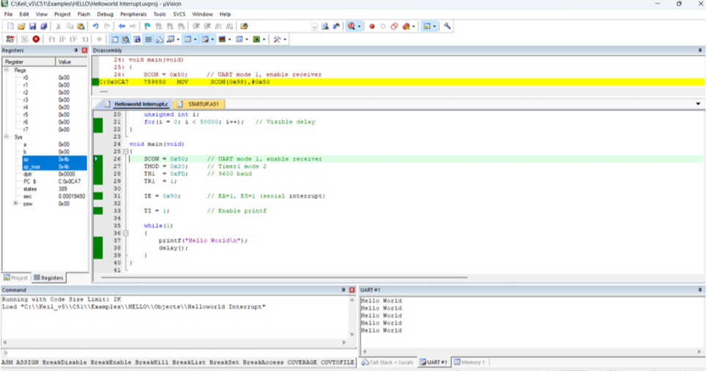
- During interruption:
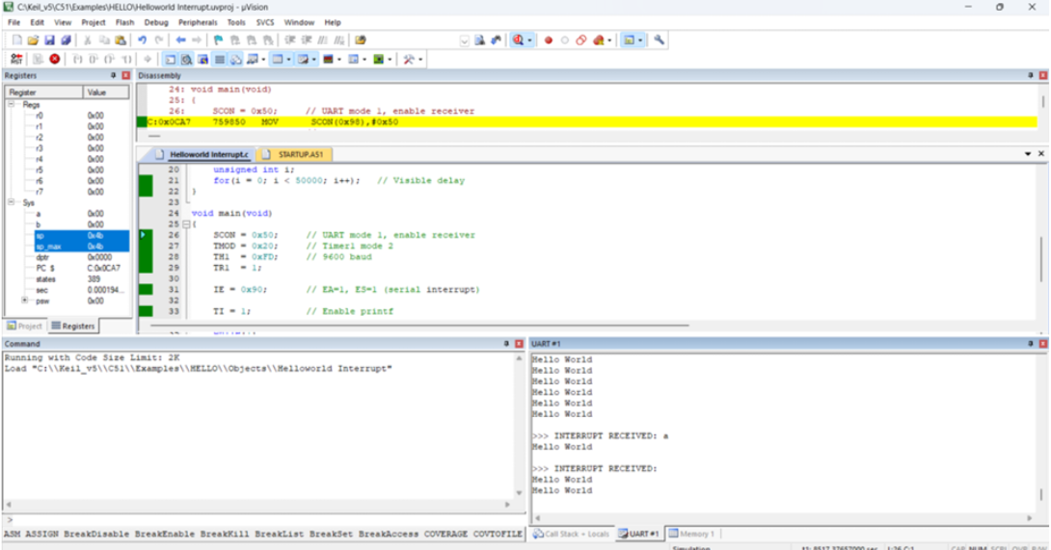
OBSERVATION:
INTERPRETATION:
• Continuous “Hello World” printing indicates main program execution
• Typing a key sets the RI flag
• Setting RI invokes the serial interrupt
• ISR executes immediately and prints the received character
• Interrupt output appears between normal program outputs
• This proves that the interrupt pre-empts normal execution
RESULT:
Thus, the serial interrupt using UART was successfully implemented and verified in Keil simulator. The interrupt was triggered upon keyboard input and serviced correctly using an Interrupt Service Routine.

